Boundary-Touching Containment

Definition
# Source: AI Source: Provided by: [Data Path: Persons Table -> ID Column: 1, Name_En Column: Motasem Essam] -> From: [ChatGPT] on [7/25/2026]
Boundary-Touching Containment is a type of region containment in which one region is completely contained within another region, while at least one point of the inner region lies on the boundary of the outer region.
If $R_{1}$is contained in $R_{2}$, and the two regions share at least one boundary point:
$$\boxed{R_{1}⊆R_{2}}$$
and
$$\boxed{∂R_{1}∩∂R_{2}≠∅}$$
then $R_{1}$is boundary-touchingly contained in $R_{2}$.
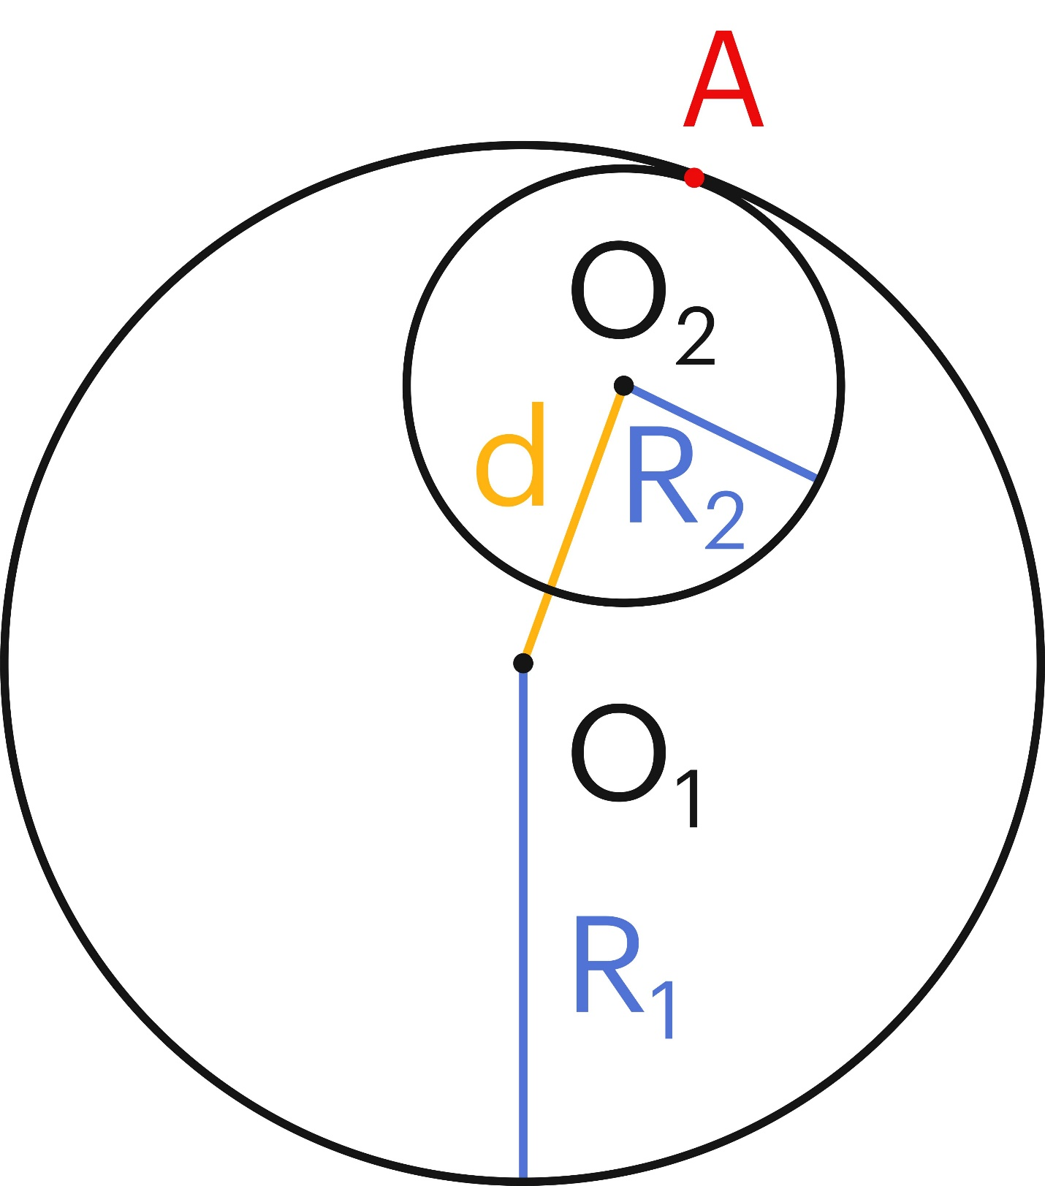
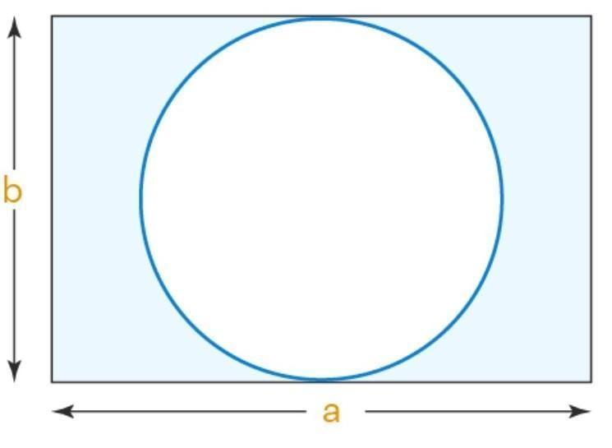
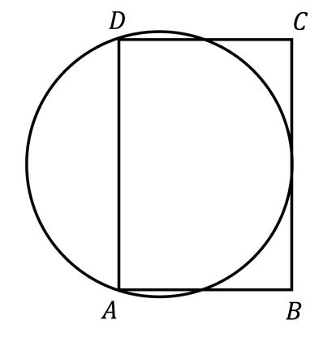
A particularly common example is internal tangency, where a smaller circle lies inside a larger circle and touches it at exactly one point.

Purpose
# Source: AI Source: Provided by: [Data Path: Persons Table -> ID Column: 1, Name_En Column: Motasem Essam] -> From: [ChatGPT] on [7/25/2026]
Boundary-Touching Containment is used to distinguish a region that is completely contained within another region but reaches the outer region's boundary from one that is completely separated from that boundary.
It is useful for identifying:
- internal tangency,
- regions touching enclosing boundaries,
- nested geometric regions,
- contact between geometric boundaries,
- and the difference between ordinary containment and strict interior containment.

Fundamental Concept
# Source: AI Source: Provided by: [Data Path: Persons Table -> ID Column: 1, Name_En Column: Motasem Essam] -> From: [ChatGPT] on [7/25/2026]
A boundary-touching containment relationship has two essential conditions:

1. Complete containment
# Source: AI Source: Provided by: [Data Path: Persons Table -> ID Column: 1, Name_En Column: Motasem Essam] -> From: [ChatGPT] on [7/25/2026]
Every point of $R_{1}$belongs to $R_{2}$:
$$\boxed{R_{1}⊆R_{2}}$$

2. Boundary contact
# Source: AI Source: Provided by: [Data Path: Persons Table -> ID Column: 1, Name_En Column: Motasem Essam] -> From: [ChatGPT] on [7/25/2026]
At least one point belongs to both boundaries:
$$\boxed{∂R_{1}∩∂R_{2}≠∅}$$
Together:
$$\boxed{R_{1}⊆R_{2} \text{and} ∂R_{1}∩∂R_{2}≠∅}$$

Mathematical Representation
# Source: AI Source: Provided by: [Data Path: Persons Table -> ID Column: 1, Name_En Column: Motasem Essam] -> From: [ChatGPT] on [7/25/2026]
The general representation is:
$$\boxed{R_{1}⊆R_{2}}$$
with:
$$\boxed{∂R_{1}∩∂R_{2}≠∅}$$
If $R_{1}≠R_{2}$, then it is a proper boundary-touching containment:
$$\boxed{R_{1}⊊R_{2} \text{and} ∂R_{1}∩∂R_{2}≠∅}$$
This is the most common case.

Boundary Point
# Source: AI Source: Provided by: [Data Path: Persons Table -> ID Column: 1, Name_En Column: Motasem Essam] -> From: [ChatGPT] on [7/25/2026]
A point $P$is a shared boundary point when:
$$\boxed{P∈∂R_{1}∩∂R_{2}}$$
Therefore:
$$P∈R_{1}$$
and:
$$P∈R_{2}$$
while $P$lies on the boundary of both regions.

Example 1 – Internally Tangent Circles
# Source: AI Source: Provided by: [Data Path: Persons Table -> ID Column: 1, Name_En Column: Motasem Essam] -> From: [ChatGPT] on [7/25/2026]
Consider a large disk:
$$R_{2}=\left\{\left(x , y\right)∣x^{2}+y^{2}≤25\right\}$$
and a smaller disk:
$$R_{1}=\left\{\left(x , y\right)∣{\left(x-3\right)}^{2}+y^{2}≤4\right\}$$
The larger circle has radius $5$, while the smaller circle has radius $2$.
The distance between their centers is:
$$d=3$$
Since:
$$d+2=5$$
the smaller circle is internally tangent to the larger circle.
Therefore:
$$\boxed{R_{1}⊊R_{2}}$$
and:
$$\boxed{∂R_{1}∩∂R_{2}≠∅}$$
Thus, this is boundary-touching containment.

Example 2 – Circle Touching a Rectangle Boundary
# Source: AI Source: Provided by: [Data Path: Persons Table -> ID Column: 1, Name_En Column: Motasem Essam] -> From: [ChatGPT] on [7/25/2026]
Suppose a circular region lies completely inside a rectangular region and touches the rectangle at one point.
Then:
$$\boxed{R_{\text{circle}}⊊R_{\text{rectangle}}}$$
while:
$$\boxed{∂R_{\text{circle}}∩∂R_{\text{rectangle}}≠∅}$$
The circle is contained in the rectangle but reaches its boundary.

Example 3 – Region Sharing a Boundary Segment
# Source: AI Source: Provided by: [Data Path: Persons Table -> ID Column: 1, Name_En Column: Motasem Essam] -> From: [ChatGPT] on [7/25/2026]
Boundary contact does not necessarily have to occur at only one point.
For example, a smaller rectangular region may share an entire portion of the boundary of a larger rectangular region.
Then:
$$R_{1}⊊R_{2}$$
and:
$$∂R_{1}∩∂R_{2}$$
contains a line segment rather than a single point.
Therefore, boundary-touching containment can involve:
- one boundary point,
- several boundary points,
- a line segment,
- or another boundary portion.

Boundary-Touching vs Strict Interior Containment
# Source: AI Source: Provided by: [Data Path: Persons Table -> ID Column: 1, Name_En Column: Motasem Essam] -> From: [ChatGPT] on [7/25/2026]
This is one of the most important distinctions.
Boundary-touching containment
$$\boxed{R_{1}⊊R_{2} \text{and} ∂R_{1}∩∂R_{2}≠∅}$$
At least part of $R_{1}$reaches the boundary of $R_{2}$.
Strict interior containment
$$\boxed{R_{1}⊂int⁡\left(R_{2}\right)}$$
Every point of $R_{1}$is inside the interior of $R_{2}$.
Therefore, for ordinary regions:
$$\boxed{R_{1}⊂int⁡\left(R_{2}\right)⇒∂R_{1}∩∂R_{2}=∅}$$
So the two conditions describe opposite boundary behavior.

Boundary-Touching vs Proper Containment
# Source: AI Source: Provided by: [Data Path: Persons Table -> ID Column: 1, Name_En Column: Motasem Essam] -> From: [ChatGPT] on [7/25/2026]
Boundary-touching containment is often a special case of proper containment.
General proper containment:
$$\boxed{R_{1}⊊R_{2}}$$
Boundary-touching proper containment adds:
$$\boxed{∂R_{1}∩∂R_{2}≠∅}$$
Therefore:
$$\boxed{\text{Boundary-Touching Containment}⊂\text{Proper Region Containment}}$$
when the regions are different.

Boundary-Touching vs Equal Regions
# Source: AI Source: Provided by: [Data Path: Persons Table -> ID Column: 1, Name_En Column: Motasem Essam] -> From: [ChatGPT] on [7/25/2026]
Equal regions satisfy:
$$\boxed{R_{1}=R_{2}}$$
Boundary-touching proper containment satisfies:
$$\boxed{R_{1}⊊R_{2}}$$
Therefore, the regions are not equal.
For proper boundary-touching containment:
$$\boxed{R_{1}≠R_{2}}$$

Boundary-Touching vs Overlap
# Source: AI Source: Provided by: [Data Path: Persons Table -> ID Column: 1, Name_En Column: Motasem Essam] -> From: [ChatGPT] on [7/25/2026]
Two regions can overlap without one containing the other.
Boundary-touching containment
$$R_{1}⊊R_{2}$$
with:
$$∂R_{1}∩∂R_{2}≠∅$$
General overlap
$$R_{1}∩R_{2}≠∅$$
but neither region necessarily contains the other.
Thus:
$$\boxed{\text{Boundary contact does not by itself imply containment}}$$
The containment condition must also be satisfied.

Boundary-Touching vs Disjointness
# Source: AI Source: Provided by: [Data Path: Persons Table -> ID Column: 1, Name_En Column: Motasem Essam] -> From: [ChatGPT] on [7/25/2026]
Disjoint regions satisfy:
$$\boxed{R_{1}∩R_{2}=∅}$$
Boundary-touching regions share at least one point:
$$\boxed{R_{1}∩R_{2}≠∅}$$
Therefore, they are not disjoint.

Boundary Contact Can Occur in Different Ways
# Source: AI Source: Provided by: [Data Path: Persons Table -> ID Column: 1, Name_En Column: Motasem Essam] -> From: [ChatGPT] on [7/25/2026]
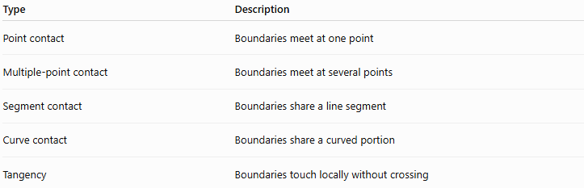
Type | Description
Point contact | Boundaries meet at one point
Multiple-point contact | Boundaries meet at several points
Segment contact | Boundaries share a line segment
Curve contact | Boundaries share a curved portion
Tangency | Boundaries touch locally without crossing

Internal Tangency
# Source: AI Source: Provided by: [Data Path: Persons Table -> ID Column: 1, Name_En Column: Motasem Essam] -> From: [ChatGPT] on [7/25/2026]
Internal tangency is a particularly important special case.
Two circles are internally tangent when the smaller circle lies inside the larger circle and their circumferences touch at exactly one point.
For circles with radii $r$and $R$, where:
$$R>r$$
internal tangency occurs when the distance between their centers is:
$$\boxed{d=R-r}$$
In terms of their regions:
$$\boxed{R_{1}⊊R_{2}}$$
and:
$$\boxed{∣∂R_{1}∩∂R_{2}∣=1}$$
for the usual circular case.

Topological Interpretation
# Source: AI Source: Provided by: [Data Path: Persons Table -> ID Column: 1, Name_En Column: Motasem Essam] -> From: [ChatGPT] on [7/25/2026]
For a boundary-touching contained region:
$$R_{1}⊆R_{2}$$
but generally:
$$R_{1}⊄int⁡\left(R_{2}\right)$$
because at least one point of $R_{1}$lies on:
$$∂R_{2}$$
Thus, the inner region reaches the closure of the containing region but is not entirely separated from its boundary.

Important Note About Open and Closed Regions
# Source: AI Source: Provided by: [Data Path: Persons Table -> ID Column: 1, Name_En Column: Motasem Essam] -> From: [ChatGPT] on [7/25/2026]
Boundary-touching containment depends on whether the boundaries are actually included in the regions.
For example, a closed disk:
$$x^{2}+y^{2}≤r^{2}$$
contains its boundary.
An open disk:
$$x^{2}+y^{2}<r^{2}$$
does not contain its boundary.
Therefore, when defining containment precisely, distinguish between:
- the region itself,
- its boundary,
- and whether the boundary is included.
The geometric boundaries can touch even when the corresponding open regions do not contain their boundary points.

Properties

1. It Implies Ordinary Containment
# Source: AI Source: Provided by: [Data Path: Persons Table -> ID Column: 1, Name_En Column: Motasem Essam] -> From: [ChatGPT] on [7/25/2026]
$$\boxed{R_{1}⊊R_{2}⇒R_{1}⊆R_{2}}$$

2. It Implies Boundary Contact
# Source: AI Source: Provided by: [Data Path: Persons Table -> ID Column: 1, Name_En Column: Motasem Essam] -> From: [ChatGPT] on [7/25/2026]
By definition:
$$\boxed{∂R_{1}∩∂R_{2}≠∅}$$

3. It Is Not Symmetric
# Source: AI Source: Provided by: [Data Path: Persons Table -> ID Column: 1, Name_En Column: Motasem Essam] -> From: [ChatGPT] on [7/25/2026]
If:
$$R_{1}⊊R_{2}$$
then $R_{2}$is not contained in $R_{1}$.
Therefore, boundary-touching containment is directional.

4. It Is Not the Same as Strict Interior Containment
# Source: AI Source: Provided by: [Data Path: Persons Table -> ID Column: 1, Name_En Column: Motasem Essam] -> From: [ChatGPT] on [7/25/2026]
If:
$$R_{1}⊊R_{2}$$
and:
$$∂R_{1}∩∂R_{2}≠∅$$
then:
$$R_{1}⊄int⁡\left(R_{2}\right)$$

5. It Can Be Transitive Only as Containment
# Source: AI Source: Provided by: [Data Path: Persons Table -> ID Column: 1, Name_En Column: Motasem Essam] -> From: [ChatGPT] on [7/25/2026]
Suppose:
$$R_{1}⊊R_{2}$$
and:
$$R_{2}⊊R_{3}$$
Then:
$$R_{1}⊊R_{3}$$
but $R_{1}$does not necessarily touch the boundary of $R_{3}$.
Therefore, proper containment is transitive, but boundary-touching containment is not necessarily transitive as a complete relationship.

Comparison Table
# Source: AI Source: Provided by: [Data Path: Persons Table -> ID Column: 1, Name_En Column: Motasem Essam] -> From: [ChatGPT] on [7/25/2026]
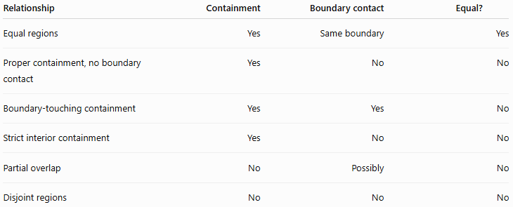
Relationship | Containment | Boundary contact | Equal?
Equal regions | Yes | Same boundary | Yes
Proper containment, no boundary contact | Yes | No | No
Boundary-touching containment | Yes | Yes | No
Strict interior containment | Yes | No | No
Partial overlap | No | Possibly | No
Disjoint regions | No | No | No

Relationship with Region Containment
# Source: AI Source: Provided by: [Data Path: Persons Table -> ID Column: 1, Name_En Column: Motasem Essam] -> From: [ChatGPT] on [7/25/2026]
A useful hierarchy is:
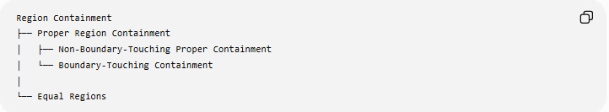
Region Containment
├── Proper Region Containment
│ ├── Non-Boundary-Touching Proper Containment
│ └── Boundary-Touching Containment
│
└── Equal Regions
Strict interior containment can be treated as another condition of proper containment:
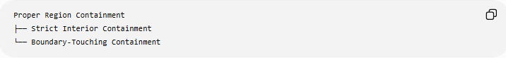
Proper Region Containment
├── Strict Interior Containment
└── Boundary-Touching Containment
This is useful because these two categories distinguish the two major boundary cases:
$$\boxed{R_{1}⊊R_{2}}$$
with either:
$$\boxed{R_{1}⊂int⁡\left(R_{2}\right)}$$
or:
$$\boxed{∂R_{1}∩∂R_{2}≠∅}$$

Real-World Applications
# Source: AI Source: Provided by: [Data Path: Persons Table -> ID Column: 1, Name_En Column: Motasem Essam] -> From: [ChatGPT] on [7/25/2026]
Architecture
A room may occupy an area inside a building while one of its boundaries touches the building's outer boundary.
CAD
A component may be positioned inside a larger geometric enclosure while touching its wall.
GIS
A geographic region may be completely contained within another administrative region while sharing part of its boundary.
Computer Graphics
A graphical object may lie inside a clipping or viewport region while touching its edge.
Robotics
A robot's operating region may fit inside a larger workspace and reach the workspace boundary.
Engineering
A manufactured component may fit inside a housing while making contact with one or more internal walls.

Key Points
# Source: AI Source: Provided by: [Data Path: Persons Table -> ID Column: 1, Name_En Column: Motasem Essam] -> From: [ChatGPT] on [7/25/2026]
- Boundary-Touching Containment means one region is contained within another and their boundaries have at least one common point.
- The fundamental conditions are:
$$\boxed{R_{1}⊆R_{2}}$$
and:
$$\boxed{∂R_{1}∩∂R_{2}≠∅}$$
- When the regions are different:
$$\boxed{R_{1}⊊R_{2}}$$
- Internal tangency of circles is a classic example.
- The boundaries may share one point, several points, or a larger boundary portion.
- It differs from strict interior containment because the inner region reaches the outer boundary.
- Boundary contact alone does not imply containment.
- Boundary-touching containment is directional and is not necessarily transitive as a complete relationship.

Conclusion
# Source: AI Source: Provided by: [Data Path: Persons Table -> ID Column: 1, Name_En Column: Motasem Essam] -> From: [ChatGPT] on [7/25/2026]
Boundary-Touching Containment describes a special form of region containment where the inner region is completely contained within the outer region but touches its boundary:
$$\boxed{R_{1}⊊R_{2} \text{and} ∂R_{1}∩∂R_{2}≠∅}$$
It is especially important for describing internal tangency and geometric contact. In a geometry taxonomy, it is best treated as a specialized form of Proper Region Containment, distinguished from Strict Interior Containment by whether the inner region reaches the boundary of the containing region.

